 | 20.1.6 Editors - NLA Editor - Track Menu
Table of content
NLA Editor - Track Menu 1
Delete 1
Track Ordering 1
Remove Empty Animation Data 1

NLA Editor - Track Menu
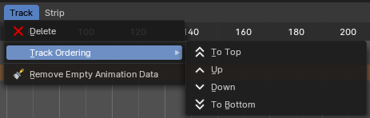
This menu contains functionality to manage the tracks.

Delete
Deletes the selected track.

Track Ordering
Order the tracks.

Remove Empty Animation Data
Removes tracks that are empty.

